Free Trees for Fall Planting

Providing up to 10 free trees

for fall tree-planting events & ReTree Nebraska celebrations across Nebraska

Deadline: July 31, First-Come First-Served. Western NE (Panhandle) recipients are encouraged
to have trees planted by October 15. Trees in other locations should be planted by November 15.

The purpose of Free Trees for Fall Planting, a collaborative effort of the Nebraska Forest Service and Nebraska Statewide Arboretum, is to help enable the planting of trees during the fall of 2019 in conjunction with ReTree Nebraska Week and other planting events. ReTree Nebraska week is September 22-28, 2019, yet trees can be planted any time between September 1st and November 15, 2019 (October 15 for Panhandle). The recipient’s event will be considered a ReTree Nebraska event. The Free Trees for Fall Planting has several goals:

- Celebrate trees and promote the value of healthy trees for a healthy community.
- Prioritize tree planting in high impact areas, such as along streets and neighborhoods of highest need.
- Plant at least 500 high-quality trees in Nebraska communities in conjunction with tree-related educational events and community celebrations to promote trees and fall planting.
- Award tree advocates by giving priority to ReTree Nebraska ambassadors, Tree City USA tree boards, Tree Campus USA schools, Nebraska Statewide Arboretum curators, individuals volunteering/supporting community forestry programs and Project Learning Tree facilitators.
- Assist volunteers and non-profit partners such as business improvement districts, neighborhood associations, government agencies, and other public or private entities with tree planting in public spaces and areas of civic importance.
- Promote the healthy establishment and ongoing care of newly-planted trees.
- Diversify the community forest by promoting a broader diversity of native and well-adapted non-native tree species recommended by ReTree Nebraska. A special emphasis will be placed on the planting of ReTree Nebraska’s 17 for 2017 underutilized trees species.
- Provide educational opportunities for people to learn more about trees and their proper selection, siting, planting and care.

_______________

Free Trees for Fall Planting is supported by:
the Nebraska Statewide Arboretum’s Trees for Nebraska Towns Initiative,
funded by and the Nebraska Environmental Trust;
and the Nebraska Forest Service’s Landscape Scale Restoration grant, funded by the US Forest Service.

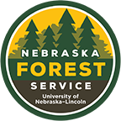
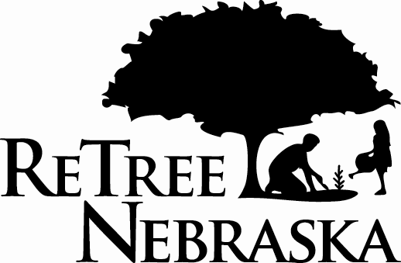
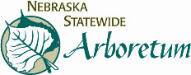
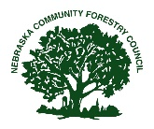
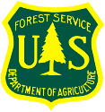
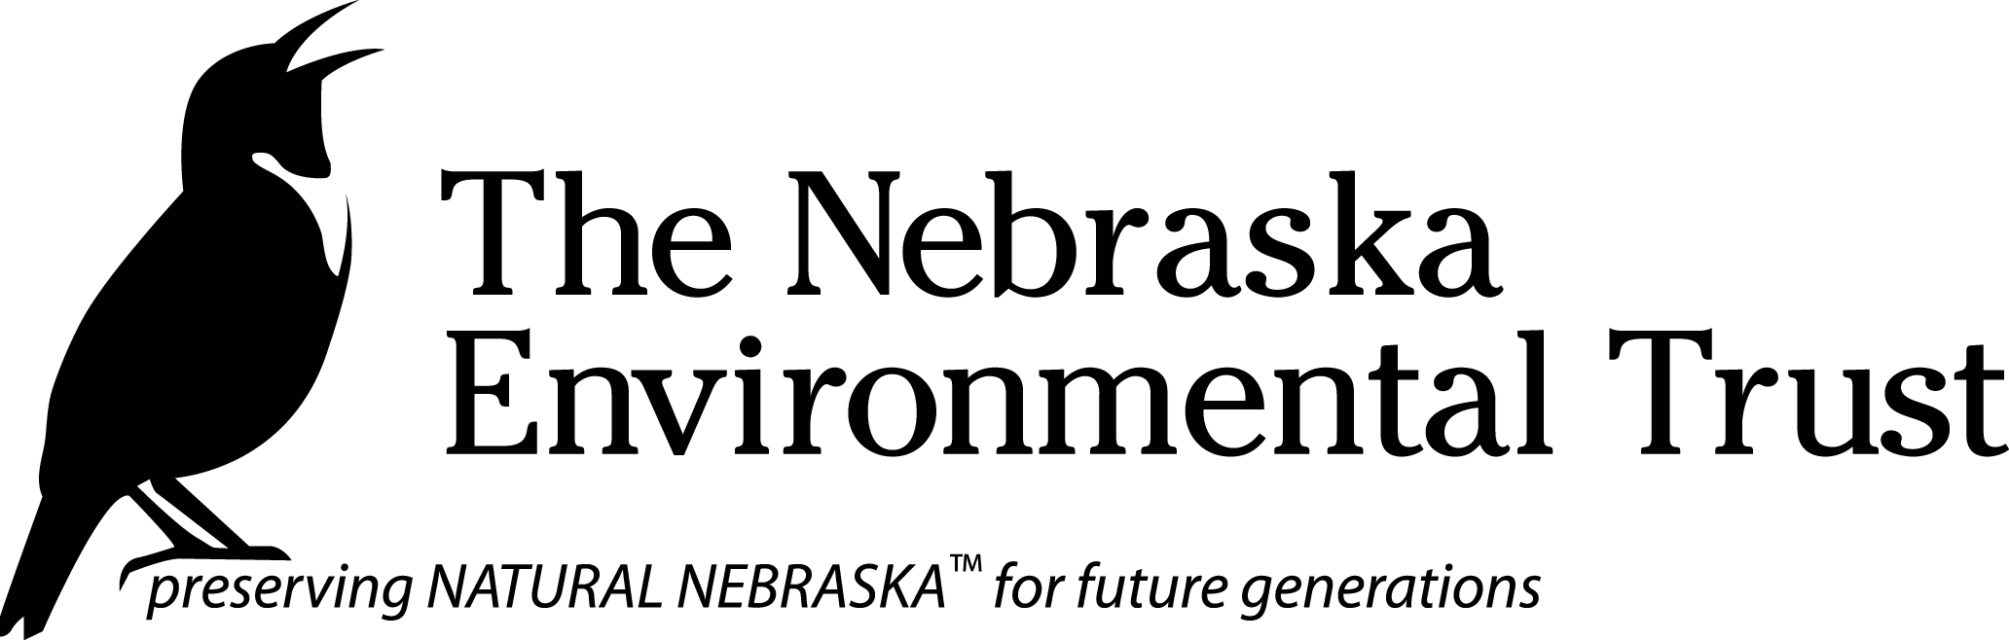
Free Trees for Fall Planting – Information and Criteria

- The Free Trees for Fall Planting Program Provides Trees: Support from the Nebraska Environmental Trust and the US Forest Service Landscape Scale Restoration grants is used to provide trees and education about trees. The program does not provide direct funding for trees to recipients but provides pre-selected trees to recipients.

- Plant Quality & Size: Only the highest-quality trees will be utilized in the initiative. A special emphasis will be placed on high-quality root systems—smaller trees with better roots. As such the expected size for most trees will be 1 -1.25” caliper or smaller and 4-12’ tall. Trees are intended to be easier for volunteers to handle.

- Who Can Apply: Anyone is eligible to submit a request for trees. Priority will be given to high-impact projects, such as street trees and neighborhoods of higher need, and to applicants who are NCFC Members, ReTree Nebraska ambassadors, Tree City USA tree boards, Nebraska Statewide Arboretum curators, individuals volunteering/supporting community forestry programs and Project Learning Tree facilitators. Schools, non-profit groups and civic organizations are encouraged to apply. Individuals must represent a group or organization. NOTE: All applicants must receive written permission from property owners/managers before planting.

- Maximum/Minimum Tree Request: A maximum of 10 trees will be allowed for any single request. The minimum awarded will be one. Recipients, especially those requesting less than 5 trees, MAY be required to pick up from a regional drop site. High impact projects (street trees, high need neighborhoods, etc.) and projects with an extensive outreach component will be given priority to receive the maximum number of trees.

- Tree Selection: ReTree Nebraska will work with applicants to select trees for each project from a limited number of trees made available to this program. Emphasis will be on a diversity of large-maturing trees (over 40 feet).

- Project Location(s): Projects must be located in Nebraska and on property of civic importance that provides clear public benefit. Eligible planting sites include, but are not limited to street ROW, parks, school grounds, college campuses, the grounds of civic buildings, recreation areas, common areas and cemeteries. Trees can be planted in front and side yards of private property if they will help shade public streets and sidewalks.

- Matching Requirement: All projects are required to contribute an in-kind match by including an outreach, educational and/or media component in the tree planting to increase public awareness of the benefits of trees and the need for diversity and proper tree care. A cash match may be required for trees planted on private property. Assistance is available to promote your event, including a press release template and educational materials. Tree recipients will be required to keep ReTree apprised of event plans so that the event is included in a statewide promotion of ReTree Nebraska week. The Nebraska Community Forestry Council, Nebraska Forest Service District Foresters or Community Forestry Sustainable Landscapes staff, ReTree Nebraska ambassadors or other tree advocates may be available to attend events upon request.

- Site Plan: A map/image (such as Google map) showing the proposed planting should be submitted with the application. Submit to kweyers2@unl.edu. Include the email subject: ‘2019 Mini Grant – (INSERT COMMUNITY)’

- Post-Planting Maintenance: All trees will be expected to be properly maintained after planting.

- Project Completion Deadline: Projects should be implemented between September 1 and November 15, 2019 (October 15 for Panhandle) unless an extension has been requested and granted. If possible, projects should be implemented and/or promoted around ReTree week of September 22-28.

- Post-project reporting: All grant recipients must provide total number of volunteer hours.

- Application Deadline: July 31; qualifying projects/applicants will be assisted on a first-come, first-served basis.

- Additional information, including a press release template and educational articles, will be available.

Direct questions to: Kendall Weyers: (402) 472-6693; kweyers2@unl.edu

Free Trees for Fall Planting - Application

All applications must be emailed to Kendall Weyers at kweyers2@unl.edu. Please keep a copy for your records.

Name of project:
Planting address or general location:

Event sponsor (if any):
Project coordinator:

Mailing address of coordinator:
Daytime phone number(s) of coordinator:
E-mail address of coordinator (required):

Project will be completed on land owned by:

Project will be maintained by:

Total number of trees requested (please only request a quantity you are sure you need):

Preferred species (Final species choices will be determined by ReTree. Species may include the following: various oaks, sugar maple, Kentucky coffeetree, Northern pecan, hackberry, catalpa, sycamore, baldcypress, American linden, silver linden, black gum, black cherry, hybrid elm and amur maackia):

Proposed event name:
Proposed planting date:

Please briefly describe the scope and expected outcomes of the project.
- Public benefit of planting at selected location:
- Source of volunteers and anticipated number of volunteer hours involved:
- Planned educational and/or public outreach efforts (e.g. newspaper article, radio interview, etc.):

Submit completed form to kweyers2@unl.edu

