2022 ORDER FORM - FIRE PREVENTION MATERIALS
NEBRASKA FOREST SERVICE
- Please complete the two columns on the right side of form, listing the number of items and the cost for those quantities
- Add 10% to the total amount for your order for shipping and handling
- Enclose a check for the total amount with your order; payable to Nebraska Forest Service
- If you have any questions, please call Eric Moul at 308-289-9821, or email at emoul2@unl.edu

UPS WILL NOT SHIP TO P.O. BOX:  NAME: ____________________________________________  ADDRESS: _________________________________________  CITY, ST, ZIP: _______________________________________  DAYTIME PHONE: ___________________________________  EMAIL:______________________________________ | Mail to: NEBRASKA FOREST SERVICE  UNIVERSITY OF NEBRASKA – EAST CAMPUS  201C FORESTRY HALL  LINCOLN, NE 68583-0815  Or  Attn: Eric Moul  Adams County Extension  2975 S. Baltimore Ave.  Hastings, NE 68901
DATE ORDER IS NEEDED: _________________________

Shipped DATE: ______________# of boxes __________
Product Description | Unit size | Cost per Unit | Number  ordered | Total  cost
Activity Book for Smokey’s Friends (8 pg. black/white, age 7-12) | Pkg/100 | $12.00
Air Tanker Glider Plane (“Prevent Wildfires!” / Wildfire Blaze Buster) | Pkg/10 | $11.00
Bag/ Chip Clip (Smokey Bear / 5 assorted colors) | Pkg/20 | $7.00
Balloon (imprint “Prevent Wildfires,” variety of colors) | Pkg/100 | $10.50
Baseball (Smokey Bear, paw print, prevention message) | Each | $2.50
Bookmarks (Smokey Bear with fire prevention msg - in color) | Pkg/100 | $4.00
Car Magnet – Smokey Bear | Pkg/10 | $10.00
Carabiner - Get Your Smokey On! (red/blue/green assortment) | Pkg/30 | $10.00
Comic Book - The True Story of Smokey Bear | Pkg/100 | $29.00
Coloring Book- For Smokey’s Friends | Pkg/100 | $12.00
Compass & Thermometer Combination Zipper Pull (Smokey Bear image) | Pkg/50 | $33.00
Eraser (Smokey’s face with prevention message, 5 colors) | Pkg/50 | $6.00
Fire Safety Outdoors Bulletin (Smokey’s msg on camping, cooking, etc.) | Pkg/200 | $21.00
Flying Disk (Smokey’s face & prevention message in 5 colors) ANEW!A | Pkg/50 | $14.50
Jar Opener - Smokey w/ Prevent Wildfires! (PVC, 5 assorted colors) | Pkg/25 | $16.50
Lapel Pin (Badge-shaped, Smokey’s Fire Patrol, w/ Smokey’s face in center) | Pkg/50 | $16.50
Litterbag (Smokey Bear’s image) | Pkg/25 | $5.50
Pens – Smokey Bear (Black ink) | Pkg/20 | $10.50
Pencil Sharpener (Smokey’s face, “Only You,” assorted colors) | Pkg/50 | $10.00
Pencils (5 colors w/ prevention messages) | Pkg/144 | $12.00
Poster (Smokey’s Five Fire Prevention Rules, 5 sets of 5, 12” x 18”) | Pkg/25 | $16.50
Rulers (Smokey Bear / 5 colors) | Pkg/100 | $17.50
Stickers (1 roll of stickers with Smokey’s face on each sticker) | Pkg/500 | $5.50
Stickers (3” Smokey die-cut fire patrol badge) | Pkg/35 | $3.50
Temporary Tattoo (4 Smokey Bear images, apply with water) | Pkg/200 | $10.00
Water Bottle (Smokey Bear / 5 assorted colors) | Each | $2.50
Window Cling (7” diameter, full color, with Smokey & prevention msg) | Pkg/25 | $9.50
Wristband (snap/slap bracelet in 5 assorted colors) | Pkg/25 | $16.50
Wristband (orange/yellow/brown/green silicone rubber) | Pkg/100 | $9.00
PLEASE FIGURE TOTAL ON OTHER SIDE / NEXT PAGE
 |  |  |  |  | SUBTOTAL
 |  |  |  |  | 10% SHIPPING & HANDLING
 | TOTAL
DEPARTMENTAL CHECKS ONLY – NO PERSONAL CHECKS

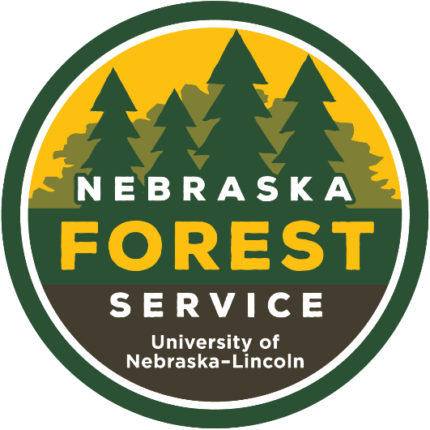
www.nfs.unl.edu

